“Smart Hall Room Using IOT”



Bangladesh University of Business and Technology, BUBT Mirpur-2, Dhaka-1216
Department of Computer Science and Engineering.

“Smart Hall Room Using IOT”
A
Project Report Submitted in partial fulfillment
Of the requirements for the course of
Internet of Things-IOT (CSE-425)

[CSE (Diploma Holders) Intake 31, Section 01]

Project Guide | Submitted By
Md. Hasibur Rahman Lecturer  Department of  Computer Science & Engineering, BUBT | ✔Muktadur Rahaman  18191203010  ✔Md. Aminur Rahman  18191203013  ✔Md. Towfique Hasan Rakib  18191203012  ✔Prottay Kumar Biswas  18191203018

TABLE OF CONTENTS

Chapter 1: Introduction Chapter 2: Literature Review Chapter 3: Methodology Chapter 4: Circuit Diagram
Chapter 5: Real Pictures and Screenshot Chapter 6: Cost
Chapter 7: Performance andResults Chapter 8: Conclusion & Limitation Chapter 9: Society &Ethics

Chapter 1
Introduction

In today's world, there is a continuous need for automatic appliances. With the increase in standard of living, there is a sense of urgency for developing circuits that would ease the complexity of life. Many times we need to monitor the people visiting some place like Hall Room. To provide solution for this we am going to implement a project called "Smart Hall Room" with automatic room (light, Fan) control.

Basic concept behind this project is the device counts the total number of people entering through the gate and also the total number of people leaving through the gate. When no people are inside the room, i.e. the total number of people is zero then the room light and fan is turned off. Also when any person entry into the room then the sensor count it and same time the system automatically on a light and a fan. The sensor continually count the number of entries people. When number five person into the hall room the system will continue one fan and light. When the six number of person entry into the hall room this time the system will automatically on another fan and light. In this system continuously occur when every five number of people entry the hall room. Such as when 11 number of person entry into the room then the third number of fan and light will be open automatically.

Another IR sensor count the total number of people leaving through the gate. When a number of person leave in the room then the sensor count it, and when number of five people leave in the room this time a fan and light off automatically.

Chapter 2
Literature Review

This project is the device counts the total number of people entering through the gate and also the total number of people leaving through the gate. When no people are inside the room, i.e. the total number of people is zero then the room light and fan is turned off. Also when any person entry into the room then the sensor count it and same time the system automatically on a light and a fan. The sensor continually count the number of entries people. When number five person into the hall room the system will continue one fan and light. When the six number of person entry into the hall room this time the system will automatically on another fan and light. In this system continuously occur when every five number of people entry the hall room. Such as when 11 number of person entry into the room then the third number of fan and light will be open automatically. Another IR sensor count the total number of people leaving through the gate. When a number of person leave in the room then the sensor count it, and when number of five people leave in the room this time a fan and light off automatically.

Chapter 3
Methodology

Required Modules :
Hardware requirements:
- Arduino Uno
- IR Sensor
- Relay Module
- Bread Board

Software and tools required:
- Arduino IDE

Arduino Uno:

The Arduino Uno R3 with Cable is a microcontroller board based on the ATmega328 (datasheet). It has 14 digital input/output pins (of which 6 can be used as PWM outputs); 6 analog inputs, a 16 MHz ceramic resonator, a USB connection, a power jack, an ICSP header, and a reset button.
It contains everything needed to support the microcontroller; simply connect it to a computer with a USB cable or power it with an AC-to-DC adapter or battery to get started
General Specification
Model Type | UNO Rev R3
Microcontroller Chip | ATmega328
Operating Voltage (VDC) | 5
Input Voltage(Recommended) | 7-12V
Input Voltage (limit) | 6-20V
Analog I/O Pins | 6
Digital I/O Pins | 14 (of which 6 provide PWM output)
PWM Digital I/O Pins | 6
DC Current per I/O Pin (mA) | 40
DC Current for 3.3V Pin (mA) | 50
Clock Speed | 16 MHz
SRAM | 2
EEPROM | 1 KB (ATmega328)
Flash Memory | 32 KB
On Board LEDs | On/Off, L (PIN 13), TX, RX
Dimensions in mm (LxWxH) | 75 x 54 x 12
Weight (gm) | 28 (without cable)  54 (with cable)
Shipment Weight | 0.08 kg
Shipment Dimensions | 9 × 6 × 4 cm

The Uno R3 can be powered via the USB connection or with an external power supply. The power source is selected automatically.
External (non-USB) power can come either from an AC-to-DC adapter (wall-wart) or battery. The adapter can be connected by plugging a 2.1mm center-positive plug into the board’s power jack. Leads from a battery can be inserted in the GND and Vin pin headers of the POWER connector.
The board can operate on an external supply of 6 to 20 volts. If supplied with less than 7V, however, the 5V pin may supply less than five volts and the board may be unstable. If using more than 12V, the voltage regulator may overheat and damage the board. The recommended range is 7 to 12 volts.

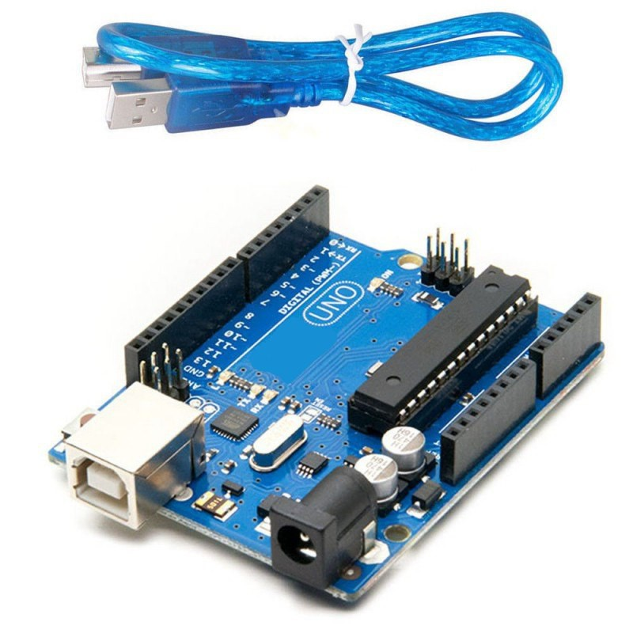
Fig-1: Arduino Uno

IR Sensor:

An infrared (IR) sensor is an electronic device that measures and detects infrared radiation in its surrounding environment. Infrared radiation was accidentally discovered by an astronomer named William Herchel in 1800. While measuring the temperature of each color of light (separated by a prism), he noticed that the temperature just beyond the red light was highest. IR is invisible to the human eye, as its wavelength is longer than that of visible light (though it is still on the same electromagnetic spectrum). Anything that emits heat (everything that has a temperature above around five degrees Kelvin) gives off infrared radiation.
There are two types of infrared sensors: active and passive. Active infrared sensors both emit and detect infrared radiation. Active IR sensors have two parts: a light emitting diode (LED) and a receiver. When an object comes close to the sensor, the infrared light from the LED reflects off of the object and is detected by the receiver. Active IR sensors act as proximity sensors, and they are commonly used in obstacle detection systems (such as in robots).Passive infrared (PIR) sensors only detect infrared radiation and do not emit it from an LED.
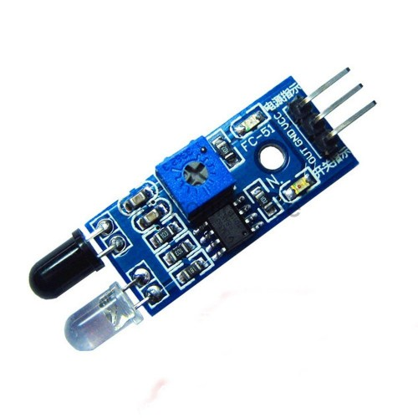

Fig-2: IR Sensor

Relay Module:
A power relay module is an electrical switch that is operated by an electromagnet. The electromagnet is activated by a separate low-power signal from a micro controller. When activated, the electromagnet pulls to either open or close an electrical circuit.
A simple relay consists of wire coil wrapped around a soft iron core, or solenoid, an iron yoke that delivers a low reluctance path for magnetic flux, a movable iron armature and one or more sets of contacts. The movable armature is hinged to the yoke and linked to one or more set of the moving contacts. Held in place by a spring, the armature leaves a gap in the magnetic circuit when the relay is de-energized. While in this position, one of the two sets of contacts is closed while the other set remains open.
When electrical current is passed through a coil, it generates a magnetic field that in turn activates the armature. This movement of the movable contacts makes or breaks a connection with the fixed contact. This force is usually provided by a spring, but gravity can also be used in certain applications. Most power relays are manufactured to operate in a quick manner.
Rated up to 70 amps, GEP’s power relay modules are designed for seamless integration in high power distribution applications. The convenient integral mounting brackets provide easy installation and accessibility. With endless options such as terminal position assurance available for wire retention, GEP Power Products’ power distribution solutions and off-road industry knowledge are second to none.
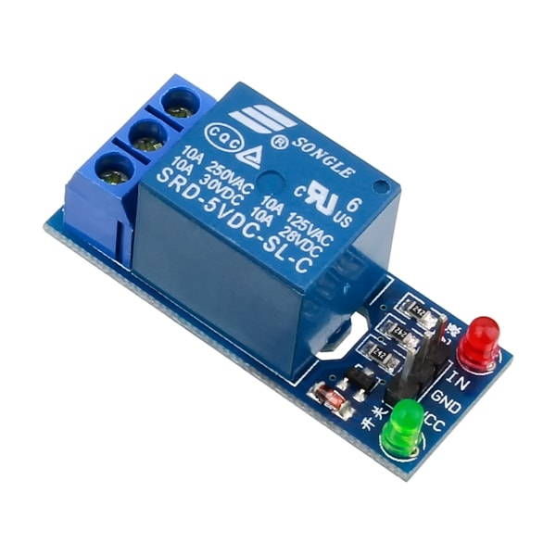
Fig-3: Relay Module

Bread Board:
A breadboard, solderless breadboard, protoboard, or terminal array board is a construction base used to build semi-permanent prototypes of electronic circuits.
Unlike stripboard (Veroboard), breadboards do not require soldering or destruction to tracks and are hence reusable. For this reason, breadboards are also popular with students and in technological education.
A variety of electronic systems may be prototyped by using breadboards, from small analog and digital circuits to complete central processing units (CPUs).
Compared to more permanent circuit connection methods, modern breadboards have high parasitic capacitance, relatively high resistance, and less reliable connections, which are subject to jostle and physical degradation. Signaling is limited to about 10 MHz, and not everything works properly even well below that frequency.
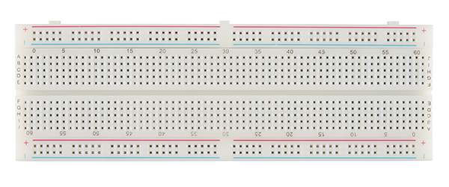
Fig-4: Bread Board

Arduino IDE :
The Arduino Integrated Development Environment - or Arduino Software (IDE) - contains a text editor for writing code, a message area, a text console, a toolbar with buttons for common functions and a series of menus. It connects to the Arduino hardware to upload programs and communicate with them.

Chapter 4
Circuit Diagram

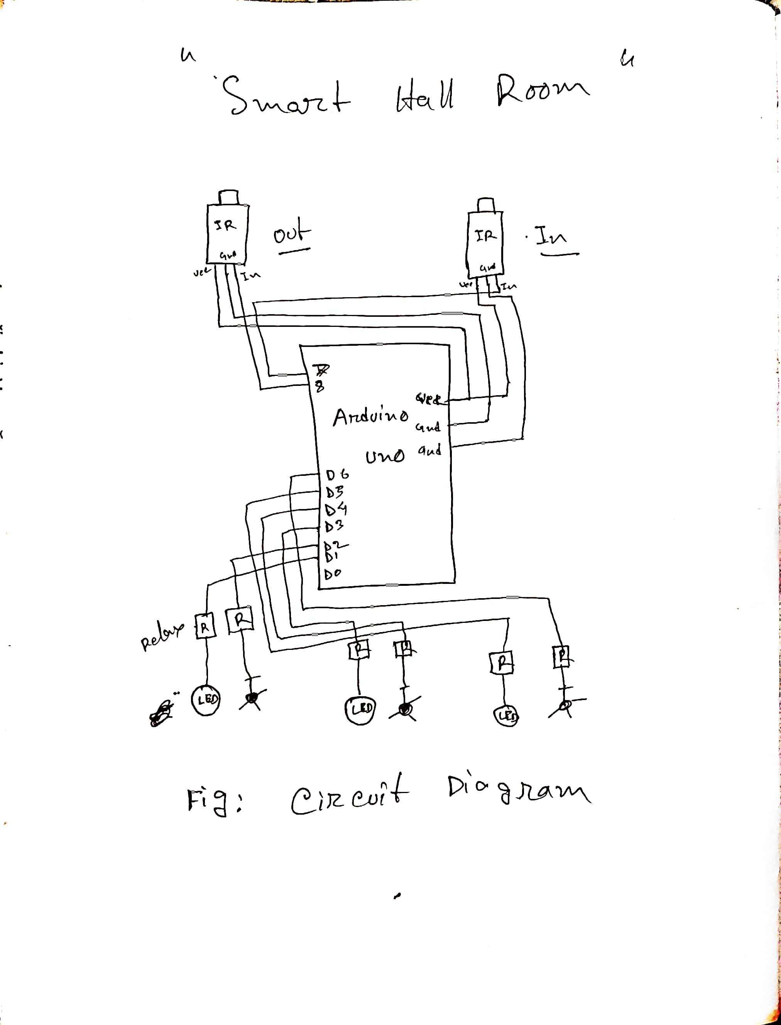

Fig: Circuit diagram
Chapter 5
Real Pictures

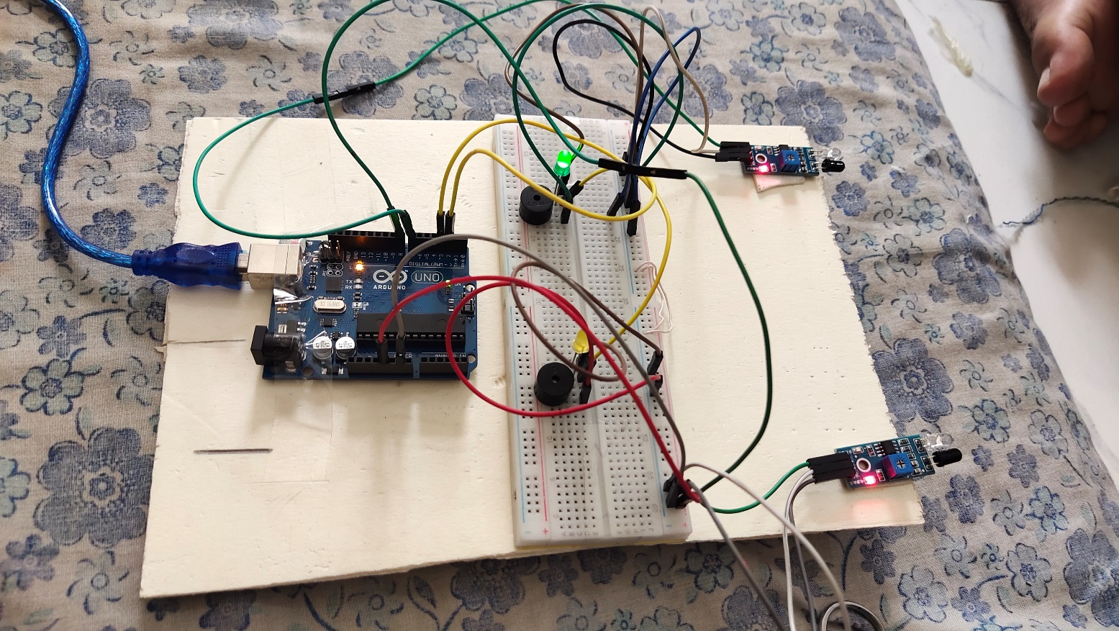

Fig: Real Picture of the project
Chapter 6
Cost

We are using cheap cost devices and sensors using our system.
The Arduino Uno is an open-source microcontroller board also a cheap microcontroller.

Node has a cheaper processor which can be used for constructing simple circuits. DHT11 is a low cost humidity and temperature sensor which provides high reliability and long term stability. It uses a capacitive humidity sensor and a thermistor to measure the surrounding air, and outputs a digital signal on the data pin (no analog input pins needed).

A water level sensor is a simple device cheapest that is used to measure the level and the volume of water inside a container.This is a conductive-type water level sensor, where the change in resistance of parallel wires over varying depths of water is converted to voltage. This is not ideal for high precision water level monitoringandisonlysuitablefortestprojects.Themodulehasthreepins:+(5V),
- (GND), and S (Signal). The S pin outputs voltage corresponding to water level.

A soil moisture sensor is a simple cheapest sensor . It is made of two exposed electrodes, and uses the fact that the more water the soil contains, the lower the

resistance between the two electrodes. The resistance can be measured using a simple voltage divider and an analog pin. While it’s very simple to construct, resistive sensors are not extremely reliable, because the exposed electrodes can degrade and get oxidized over time.

Total cost of this system will be the cheapest product on the market.

Chapter 7
Performance and Results

Chapter 8
Conclusion

The Arduino UNO has only 32K bytes of Flash memory and 2K bytes of SRAM. That is more than 100,000 times LESS physical memory than a low-end PC! And that's not even counting the disk drive!

Node mcu is an open-source firmware and development kit that helps you to prototype or build IoTproduct. Node mcu too like Arduino Uno can be programmed directly using Arduino IDE. Node mcu has 10 digital pins and only one analog pin. Communication Interface: The user must connect to the system using Node mcu that is to gain control and a dashboard to display the results will be made currently we will be using through wifi module of the Nodemcu.

ThingSpeak is available as a free service for non-commercial small projects (<3 million messages/year or ~8,200 messages/day). For larger projects or commercial applications, four different annual license types are offered: Standard, Academic, Student and Home.

IoT can take advantage of the benefits of the cloud features and resources to overcome its limitations such as storage, processing, and communication. But it has its proper limitations such as scalability and energy-efficient miningissues.

The prices of top-quality sensors and actuators are still high. Costs need to be reduced more, and an optimization model of minimum service costs needs to be implemented.

IoTbased agriculture environment to ensure that farmers receive ongoing training in order to keep up to date with the rapid changes in technology that affect farm operations from farm tofork.

There still exist several challenging research areas, such as hardware boards, interoperability of systems, ,networking and energy management, security and privacy
threats, hardware and software costs, and education challenges, which should be further investigated in the near future.

We have successfully built a proper fully functioning working model of the automatic System using limited modules. Our model takes soil parameters like moisture, wetness, temperature and weather parameters like humidity, temperature into consideration to make output more accurate. Our model has a user friendly interface which allows farmers to change threshold values of different factors. This Enables farmers to customize models to the type of crop, weather and landscape. We are utilizing features of cloud computing to store, process and monitor data. This is a very helpful substitute for an actual visit to the irrigation department office. This model also has an actuator, water pump making it an automated agriculture irrigation system. And as for the future developments this system can be improved by developing this system for large acres ofterrain.

Chapter 9
Society and Ethics

The ‘Smart Agricultural System using IoT’ is a project which was actually developed for social and agricultural development and enhancing the country's economy.This project is not harmful or threatening for our society or the agricultural system.

We think that this technology is cheap and very easy to use, and It does not interfere with any kind of legal and religious values so it will be easily accepted by people from all walks oflife.

Our project will be very helpful and it will give a positive impact on our agriculture with no social and ethical issues.

